***Husky plush dog***

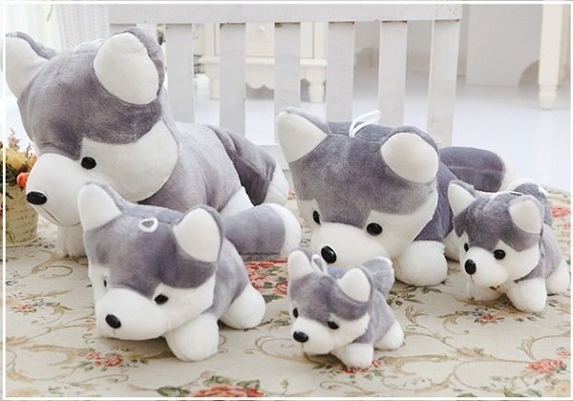

*Husky plush dog has a length of 65 cm  
This dog has 2 colors white and gray.  
The product is very suitable as a gift for girlfriends on March 8 or birthday gifts, children's gifts,"*